

___________________________________________________________________________

Artificial Intelligence (Lab)
Lab Report 5

Submitted By:

Fiza Mushtaq
SU92-BSSEM-S25-016
BSSEM-4A

Submitted To:
SIR. Rasikh Ali

- Minimax and Alpha-Beta Pruning
Task 01:
Finding the Minimax Value:
- Graph Tree:
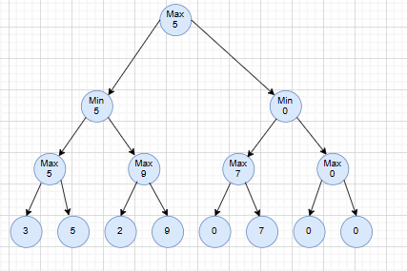

Leaf Values:
The values of the leaves are [3, 5, 2, 9, 0, 7].
Working:
A binary tree is formed using the given leaf values. Two additional zeros are included to complete the tree
MAX Level:
- MAX (3, 5) = 5
- MAX (2, 9) = 9
- MAX (0, 7) = 7
- MAX (0, 0) = 0
MIN Level:
- MIN (5, 9) = 5
- MIN (7, 0) = 0
Root MAX:
- MAX (5, 0) = 5
Result:
The final value obtained from the Minimax algorithm is 5.
Task 02:
Evaluating Leaf Nodes in Both Algorithms

A counter is used to record the number of leaf nodes visited by each algorithm
Algorithm | Final Value | Leaves Visited
Minimax | 5 | 8
Alpha-Beta Pruning | 5 | 8

Working:
Minimax searches through every leaf node before calculating the final value. Alpha-Beta pruning can avoid unnecessary branches by checking the alpha and beta limits. In this tree arrangement, no pruning condition is reached that allows a branch to be skipped. Therefore, both algorithms visit all eight leaves and produce the same final value of 5.
Task 03:
Testing a Different Leaf Arrangement
The original leaf values are rearranged to examine how their order affects the number of evaluations performed by Alpha-Beta Pruning.
Original Leaf Arrangement:
[3, 5, 2, 9, 0, 7, 0, 0] These are the original leaf arrangement values.
Rearranged Leaf Values:
[2, 9, 0, 0, 3, 5, 0, 7] are the rearranged values of the leaves.
Results:
Algorithm | Final Value | Leaves Visited
Minimax | 5 | 8
Alpha-Beta Pruning | 5 | 6

Working:
Minimax checks all eight leaf nodes to determine the final value. In comparison, Alpha-Beta pruning stops searching a branch when the alpha-beta conditions show that exploring it further cannot change the decision. Due to the new arrangement, two leaf nodes are skipped, so Alpha-Beta pruning evaluates only six leaves. Both algorithms still produce the same final value of 5.
Conclusion:
The arrangement of leaf nodes affects the efficiency of Alpha-Beta pruning. A suitable ordering can help the algorithm avoid unnecessary evaluations while keeping the minimax result unchanged.

